**Ulfgar Bloodbeard**

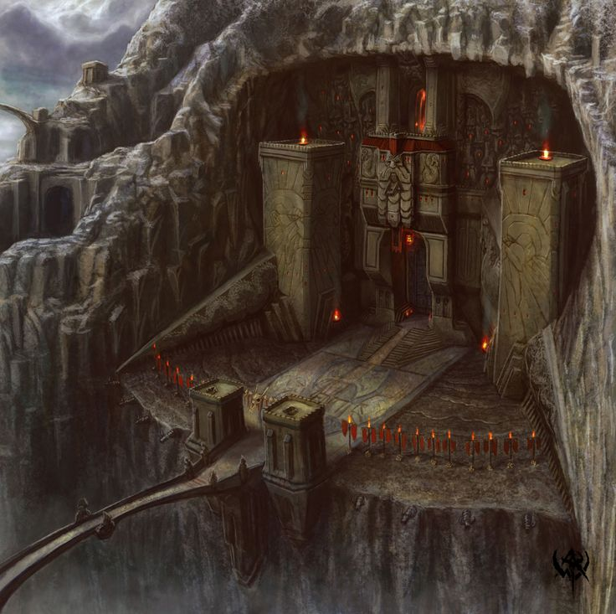 Bloodbeard, a clan known for their fearsome abilities in battle at impenetrable castle; they lived for decades in the mountain of Gaurager with the leadership of King Boendal and Queen Nalvaris and kept guarding it from invaders such as elves, orcs, trolls and many more. Their name "Bloodbeard" was from their history of battles because when they fight their beard looks like the blood from their enemies they killed and it also strikes fear in their enemies in battle. In battle the Bloodbeardsalways used their strongest army the Balyndis, composed of the finest dwarves in Gaurager. But the Bloodborn clan isn't only about battles, they also mine crystal selling it to their allied races for fortune & forging weapons and they also believed the spirit of animals give them strength to fight in battle. It was their prime they controled everything in Gaurager and as they continue King Boendal got curious of the future of his clan. King Boendal decided to ask a wizard named Vraccas for what is to come in the future and the Vraccas said "Your majesty, you will have a son destined to be a great warrior but on his day of birth a powerful force will attack mountain Gaurager". King Boendal got scared and yelled at the wizard “NEVER TELL ANYONE ABOUT WHAT YOU SEE IN THE FUTURE”. As the time past, King Boendal ordered his people to strengthen their defense and train more warriors. While the King was ordering everyone, Queen Nalvaris is already carrying the baby and were heavily guarded wherever she goes. 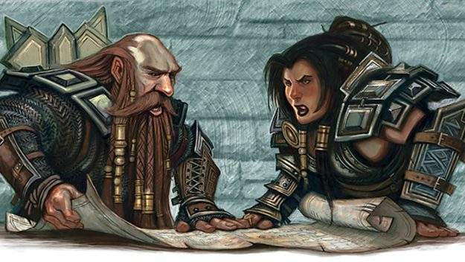 While the Bloodbeard was busy in the mountain Gaurager, their enemies Orcs, Trolls, dark elves goblins gathered and formed a temporary alliance called Sevren’s dagger to defeat their common enemy the Bloodbeard clan. Their plan was to seek a powerful wizard to help them imprisoned the great dragon of molten fire Orien against clan Bloodbeard, as they searched and searched, they finally found a wizard named Murcatto. When they asked Mucatto he was not interested to help them. So they decided to force the wizard to do it by abducting him and corrupting him so he will fight for them to destroy clan Bloodbeard. A month before the birth of King Boendal's son, Sevren's dagger was on their way to imprison Orien in the forgotten castle of Weyurn. When they arrived Mucatto was alrealy corrupted and ready to fight in their command.

A week after Sevren’s dagger arrival, they tried to tame Orien using the element of surprise and the power of Mucatto but it was not enough teamwork was their only way. After hours of fighting Orien was imprisoned, many men of Sevren’s dagger were lost but it was worth it so they set their eyes to attack the mountain of Gaurager. 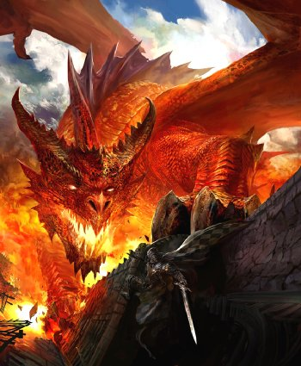

The day has finally arrived, Queen Nalvaris is about to give birth to her child but on the same time Sevren's dagger commence their attack on the mountain. As the Bloodbeard defend their mountain in the command of king Boendal, Queen Nalvaris is placed in the most secured part of the mountain. As chaos and death spread in the area, the leader of Sevren's dagger was revealed and his name was Tungdil. Tungdil paused the attack and asked for King Boendal's surrender. King Boendal responded by saying "We Bloodbeards will never surrender to weaklings like you, besides with an army like that you could only put a dent in this mountain". Tungdil got angry that King Boendal could still able to talk like that but afterwards he smiled and laugh and said "Let’s see if you could still talk like that after i do this, MEN! Release the dragon Orien". King Boendal was shocked that they have tamed Orien Dragon of molten fire to fight for them. There was no hope the Bloodbeards will survive even if they fight with the Balyndis. As Sevren's dagger release Orien, he was furious, angry and mad because they imprisoned him. He destroyed the armys of Sevren's dagger and Bloodbeard; moments before Orien enters the mountain Queen Nalvaris already gave birth to her child and King Boendal rushed to her asking “is it a girl or a boy?”. Queen Nalvaris answer "is it a boy, you should be the one to give a name". King Boendal thinks hard for a name and said “My son will be called Ulfgar, Ulfgar Bloodbeard". After that King Boendal ordered the Balyndis to join him to fend off Orien and told Queen Nalvaris to get out of the mountain and bring Ulfgar with her. As King Boendal waits with the Balyndis for Orien’s arrival, Queen Nalvaris with some escorts escaped but on her way some survivors of the Sevren’s dagger found them and attacked. After the fight, she was bleeding; but she manage to escape with Ulfgar, after a few minutes she sits down and prayed to the spirits of the animals to protect her child. Queen Nalvaris then died holding Ulfgar in her arms.

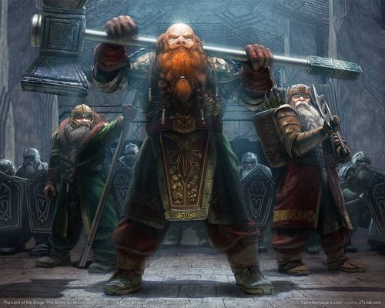

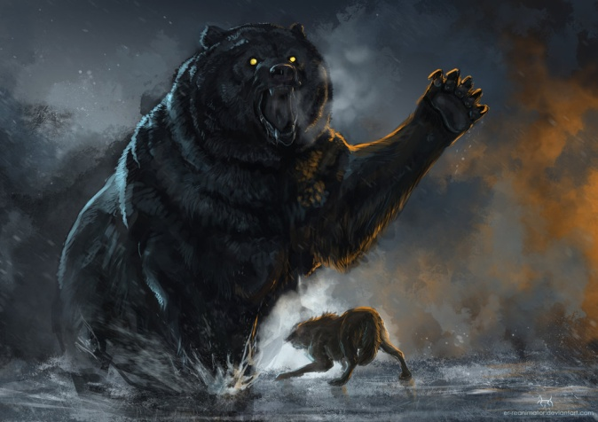

Back to the Mountain, King Boendal finally faced Orien and he told him “LEAVE!! Or we will kill you here”. Orien responded “I like your arrogance King Boendal so I will keep you alive and make you my slave but the rest of your men will be killed by me”. King Boendal responded too saying “let’s see what happens” and he charges at orient shouting “ATTACK!!!!”. After a long battle with Orien, King Boendal and the Balyndis were defeated, only King Boendal survives but enslave by Orien never to escape in the mountain of Gaurager. The mountain of Gaurager is now the home of the molten fire dragon Orien.

In the forest, Ulfgar cried for hours until a pack of dire wolves found him. They wanted to eat him but the ancient bear Durrnak show up and decided to defend Ulfgar from the dire wolves. After he fought the dire wolves, a spirit appear in front of him telling that he must take care of the child, for the child is the son of King Boendal and Queen Nalvaris and is destined to fight the molten fire dragon Orien and bring peace to mountain Gaurager again. As Durrnak was talking to the spirit; a member of the

Sevren’s dagger heard what they were saying and rushed to find other member to help sabotage the ancient cave of Durrnak. Durrnak then obeyed the spirit because he vows his life to the spirits because they are the one responsible for his giving him ominous strength and size. Durrnak then took Ulfgar with him on his way home but before they could reach his home Durrnak saw humanoid creatures destroying his home. Durrnak rages and rushed to save his home holding Ulfgar in his mouth. As he attacks the humanoid creatures, he recognized them as members of Sevren’s dagger. The members of Sevren’s dagger were shocked that Durrnak were able to get to them quickly but as they react to his speed; the claws of Durrnak slashed them already, killing them without mercy. As Durrnak see his home destroyed, he realized that Ulfgar is in danger; so he decided to find a new home and raise Ulfgar as his son.

After a few years, Ulfgar grown into a dwarf teenager in durrnak’s care; Ulfgar learned how to hunt, survive in the forest and respect the spirit of animal from his father figure Durrnak. From child to teenager, Durrnak never allowed Ulfgar to go towns or even near people because in the years he raises Ulfgar he really pictured him as his son and he doesn’t want him to get hurt. Ulfgar knowing only Durrnak as his relative obeys and understand him even he is a bear. One day, while Ulfgar and Durrnak were hunting, a group of orcs manage to trap Durrnak leave Ulfgar alone with his improvised axe and knife. As Ulfgar see Durrnak trapped, his anger fuelled his body showing rage. One of the orcs recognized that rage saying ‘THIS IS NOT POSSIBLE!, the legendary Bloodbeard battle rage, they were wiped out by the molten dragon Orien. How did you survive?” Ulfgar ignores what the orc said and attacks with brutal force. Other ran again bleeding while the ones who fought Ulfgar died. Ulfgar then freed Durrnak saying “Durrnak, it is not safe here anymore to hunt let us go back to the cave and rest”. As they walk, Durrnak thinks that it is time to let Ulfgar know the truth and let him go live like a normal dwarf; when they arrived inside the cave Durrnak told Ulfgar all he knows about what happened to him while he was a child. After Durrnak told everything, Ulfgar said “My family, I need to find them if there is any left. Durrnak thank you for taking care of me and being my father all these years but I must leave you to learn about my family the Bloodbeard”. Durrnak responded “I knew this day would come, you are old enough now; so go but boy never forget me”. Ulfgar then leaves the cave and set on a journey to find his family.

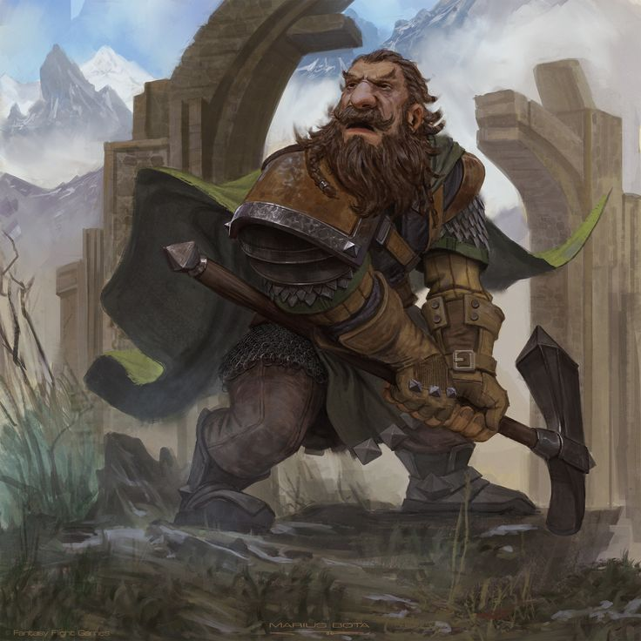

As Ulfgar continues his journey, he stumbled upon a dwarf. Ulfgar was shocked and he said “you’re a dwarf do you know something about the Bloodbeards?” The Dwarf responded “yes, I know something about them but there are no longer alive there were wiped out. What is your business with the Bloodbeards? Wait you have their beard, how?” Ulfgar answer “I am a Bloodbeard, the son of King Boendal and Queen Nalvaris”. My mother managed to escape with me outside the castle but she did not live to raise me, the ancient bear Durrnak raised me. The dwarf got curios and said “how fascinating, the last of the legendary Bloodbeard and son of Durrnak; let me introduce myself I am Einkil Ironfist come the king Fargrim will tell you all he know about the your family the Bloodbeards at our mountain here in Urgon.

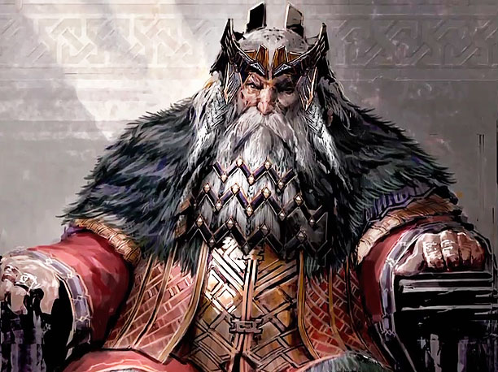

As Ulfgar enters the mountain all of the other dwarves look at him and he asked Einkil “why are they looking at me” Einkil answered “well you are the last Bloodbeard, it’s been years since a Bloodbeard stepped inside here”. As Ulfgar meet King Fargrim, king Fargrim asked “Where did you come from dwarf? Why is your beard colour like that?” Ulfgar responded “I am Bloodbeard son of King Boendal and Queen Nalvaris”. The King asked “do you wish to become one of us?” Ulfgar answered loudly “NO, I just want to find out what did my family do to become a legendary clan”. The King told him story then after he ordered his men to bring Ulfgar a new set of clothes and give food for his journey. As Ulfgar get ready for his journey, he decided to taste the rum that King Fargrim was talking about in his story. As he makes his way to a tavern he saw a dwarf girl serving rum to the customers. He sat in the chair and waits for the girl to ask him what would he like. When the girl approached Ulfgar said he would like rum then asked for her name. The girl gave him rum and said “my name is Mardred. Ulfgar asked again “can we have a chat as a drink this rum?” Mardred responded “I’m sorry, I need to serve other more customers but after work we could talk, can you wait for me” Ulfgar answer “Sure I can wait for you”.

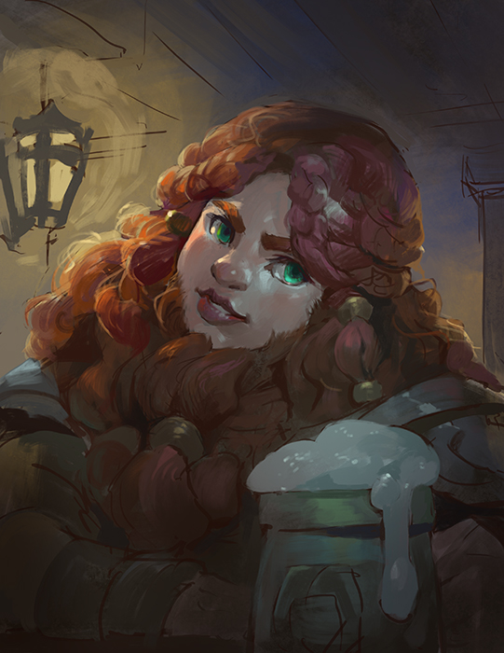

While Mardred is finishing her work, Ulfgar was thinking of how he would talk to Mardred. When Mardred came to him, he told her stories of him growing up, his family and his current journey. As Ulfgar finish his stories Mardred said “Ulfgar, you are the most interesting dwarf I talked to, maybe you could come back here and tell what happens in your journey” Ulfgar answers “are you sure? I will have a very long journey”. Mardred tells Ulfgar “then it’s going to be a long story and I can wait for it” Mardred then kissed Ulfgar and said goodbye.

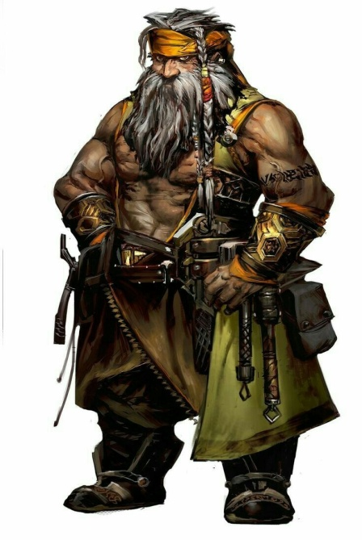

In the morning, Ulfgar still thinks of Mardred but he thought that he must first continue his journey. As his journey continues for months, he becomes closer to finding more about his clan Bloodbeard but it became difficult for him because of he has little knowledge about wielding weapons and using them. He searched and searched for a trained and he found Darrak the barbarian. Ulfgar became Darrak student because Darrak sees that Ulfgar has a potential to be a great warrior. There were only 2 students training with Darrak, Ulfgar and Thorin. They are going to have different training Thorin is training to the path of the berserker and Ulfgar decided he wants the path of the totem warrior in honour of his father figure Durrnak. Even they had different paths, Ulfgar and Thorin became friends. After 5 year of training with Darrak Ulfgar and Thorin decided to stay together and explore dungeons, cave, and magical place.

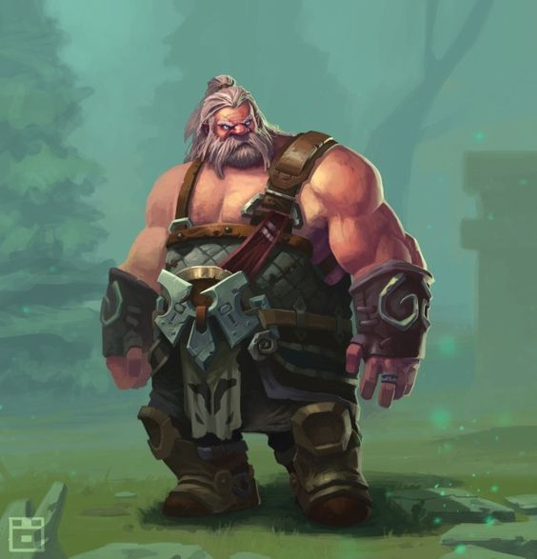

As Ulfgar and Thorin explore places, they found a tower and there Ulfgar found out about the Mountain of Gaurager his homeland and the molten fire dragon that lived inside it. He then decided to explore more places and get stronger to face the dragon, but before they could leave the tower with the information a group of humanoid creatures introduced themselves as Sevren’s dagger and said to never go inside to mountain. Ulfgar rages on them and attack, but after the combat Thorin got injured and was lucky brought to town. Ulfgar said to Thorin “get well soon I shall now continue may journey alone. Ulfgar then decided to go to belsrum to find more answers.